TSS Functions

Half-hourly transmissions to OPRA

Business Case/Overview
This includes the total traded volume by category in text format for half an hourly transmission to OPRA. The categories in this are
- Equity
- Composite
- Index
These reports are transmitted to OPRA via COPP every half an hour.

System view and requirement (Use case)
Following block diagram depicts the flow of half-hourly transmission to OPRA.
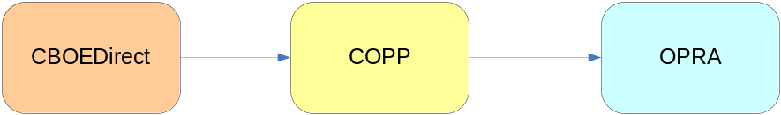
Basic Flow:
Step 1: System (CBOEDirect) starts the half hour report based on time of the day.
Step 2: System logs start of report with time stamp.
Step 3: System calculates the total volume by each category based on last sale data for each series for the report.
Step 4: System generates and saves the report.
Step 5: System sends the report to the receiver (COPP).
Step 6: System logs completion of report with time stamp.
Alternate Flows:
- System should have functionality to terminate the transmission of half an hourly report.
- System should have functionality to re-transmit the half an hourly report.
- System should have functionality to abort the transmission.
Requirement Specification
- Start Time of Transmission: First transmission needs to start at 07:30:00.
- End Time of Transmission: Last transmission to OPRA (half hourly) is done at 15:30:00.
- Frequency of Transmission: The system would generate the reports at a frequency of half an hour, for transmission to OPRA.
- Transmission of half an hour report to OPRA and NEWSWIRE will be done at same time
- The data for every half hourly transmission is cumulative.
- Training class and industry test class (if any) need to be excluded while calculating total volume for Equity, Composite and Index category.
- Computation of Total Volume by Category:
  - To calculate each category total volume, last sale for each series needs to be checked and corresponding traded quantity (volume) needs to be summed up.
  - While calculating category total volume, cancellation of trades needs to be subtracted and correction of trades needs to be accounted for.
- The system should be able to configure/parameterize the start transmission time and end transmission time for the reports.
- Transmission is aborted if the time for transmission crosses 16:30:00.
- System should have a mechanism for doing handshake with COPP.
- Communication protocol between CBOEDirect and COPP is application to application/CORBA interface.
- System needs to send the data in ASCII format to COPP. Currently TPF sends this message to COPP in EBCDIC format.
- On expiration day the end of sale may cross 15.30.00, irrespective, the last half hourly report is sent at 15.30.00.

List of affected components and systems affected
- CBOEDirect (GC and BC)
- COPP
- SA GUI
- Control M
- TPF

List the test drivers
- Test driver is required to generate last sale for each series under different categories in W_Main session.
- COPP simulator would be required to send the response to CBOEDirect. Response can be success or failure.

Data Sources:
- Product Class
- Reporting Class
- Product
- Market data summary
- Market data services

Data overview –
Following table covers various fields and description of the report transmitted to OPRA every half an hour.
 | Message Field | Description | Data Type | Format | Size
 | Equity Volume | Today’s Cumulative Total Volume of calls and puts options series with Equity as underlying from start of the day till the time transmission capture program is started. | String | Text
 | Composite Volume | Today’s Cumulative Total Volume of calls and puts options series with Composite as underlying from start of the day till the time transmission capture program is started. | String | Text
 | Index Volume | Today’s Cumulative Total Volume of calls and puts options series with Index as underlying from start of the day till the time transmission capture program is started. | String | Text

Analysis Sequence diagram
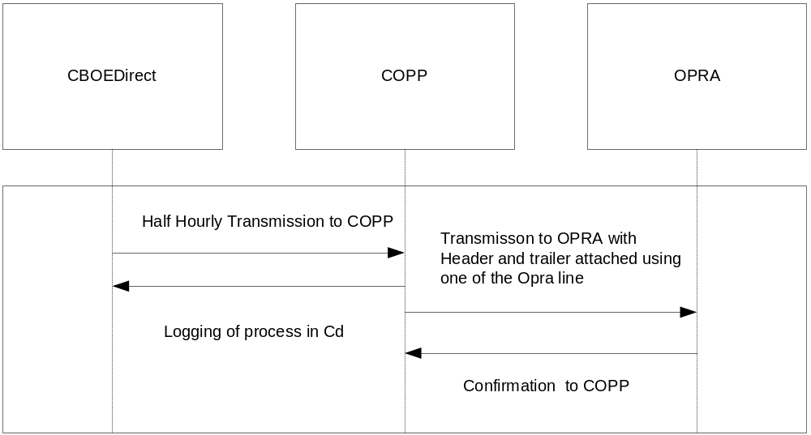

Rollout implications
- As a single report cannot be started or turned off from TPF or CBOEDirect therefore all the reports will have to be disseminated from either TPF or CBOEDirect at one go. A configurable option (switch or a flag) will be created in both CBOEDirect and TPF that can be used intraday to enable and disable the dissemination of reports. Thus reports can be disseminated from CBOEDirect and switched off from TPF but in case of any problem they can be switched off from CBOEDirect and enabled from TPF.

Non Functional Requirement

Performance requirements
- System needs to capture all information and transmit it to COPP within one minute.

Time Constraint
- Trading has started.
- Start time for first half an hourly transmission report is 07:30:00.
- End time for transmission of half hourly transmission report is 15:30:00.

Instrumentation and Monitoring process
- Process needs to be monitored for the last time the report was calculated and sent.
- System needs to log the time stamp of capturing the data and transmission to COPP.
- System should be able capture any failure message like COPP is not logged in.

Recovery and Back up procedure
- System should be able to retransmit the saved report as described in the alternate flow.
- If COPP is down or not logged in, then CBOEDirect should be able to retransmit the report whenever COPP logs in.

Additional information: (OPRA format)
Half an hourly report to OPRA is sent as Administrative message category type.
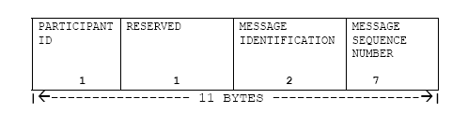
Message Header: The Message Header is part of the message text. It is supplied in each message and contains a total of 11 Bytes conforming in all cases to the following data fields:

Example of Message Header: C C 0002553
Administrative Message (unformatted) – Category C, Type = (Space filled)
- Administrative (unformatted) messages (called admin) are those messages that, because of the nature of the information they contain, cannot be readily arranged in a fixed format.
- The length of an administrative message is variable.
- For most administrative messages, the text section of the Administrative message is transmitted in free format.
Example of overall message transmitted which shows category, time and volume
08:30:01 |Line.Opraline.0 |C C 0002553TEXT EQUITYP VOLUME 0830 1^_C C 0002554TEXT COMPOSIT VOLUME 0830 0^_C C 0002555TEXT INDEXP VOLUME 0830 0^C
- Participant ID: CBOE so C
- Message Identification: 2 Byte one for each Message Category (C- Administrative) and Message Type (Space filled)
- Message Sequence Number: 7 Byte – 0002553
- TEXT
- Category: EQUITYP VOLUME
- Time: MMHH 0830
- Volume: 1
- Unit Separator: The Unit Separator (US) control character (x1F) is needed in multiple message blocks to signify the end of the preceding message but not the end of the block. An ETX control character delimits the last message.

- After US again message header with text message for other category (INDEX, COMPOSITE) is send.
- Messaging sequencing and formatting of message is done by COPP application

